**Project Report**

The project is fully working with both diffuse and specular lighting. The final outputted results can be seen in figures 1 through 5.

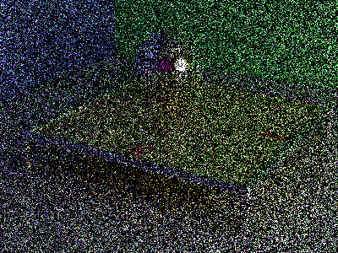

Figure 1: 1 Pass Figure 2: 8 Passes

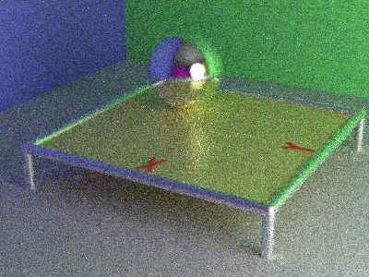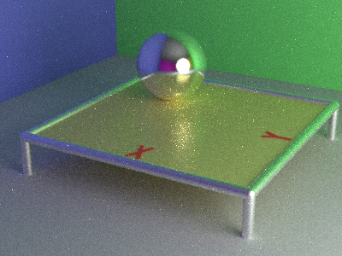

Figure 3: 64 Passes Figure 4: 512 Passes

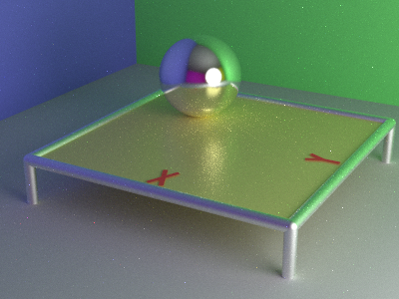

Figure 5: 4096 Passes

For this project I only had one bug, but it was a very difficult one to find the source of. The result of the bug can be seen in figures 6 and 7. The image is generally correct with the added specular reflection working. The issue is that as the image is run it doesn’t converge at the expected rate. Even after 512 passes the image is almost as noisy as the correct final version after 64 passes. The noise also seems to be unexpectedly bright. The edges where the walls meet the floor are also an important detail as they seem to give off a strange glow. This indicates that beyond the raytracer converging too slowly, it is converging to an inaccurate image.

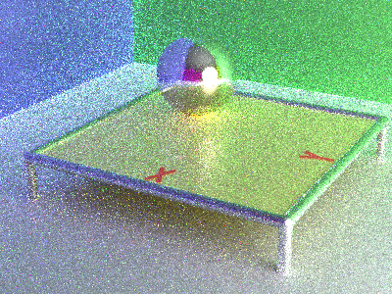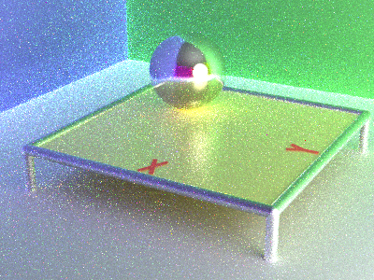

Figure 6: Too Bright 64 Passes Figure 7: Too Bright 512 Passes

After going through the code carefully and not seeing the issue I was advised to make use of my version control software. I went back through my commits that I made after finishing project 2 to determine exactly where the bug started. This helped narrow down which function the issue could be in. I then very carefully rewrote each function referencing the project handout and then comparing it to the function that I wrote the first time around. This eventually led to the discovery that the pdf function was using omegaO instead of omegaI for calculating Pd, which was the cause of the issue.